HockeyApp new App setup

Dev Internal, Staging (for QA), Submission (for CT)

1. Create New App & choose manual

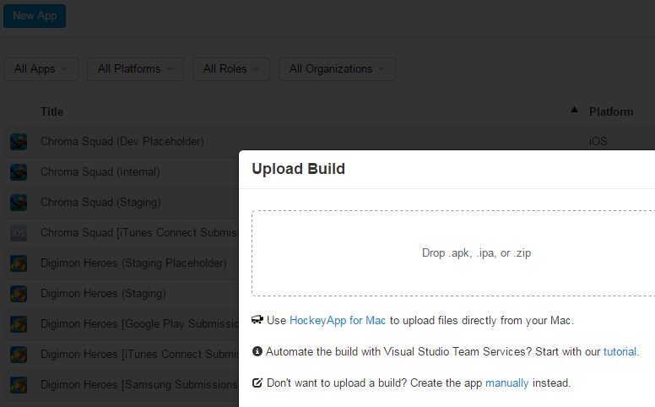

2. com.bandainamcoent.google.emoji

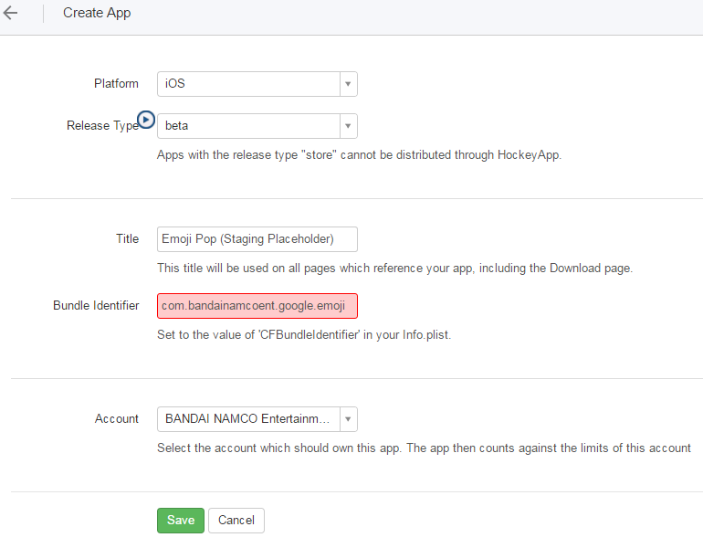

Bundle Identifier: com.bandainamcoent.google.emoji